**Green Society Public School**

**Ratnanagar-7, Sauraha, Chitwan**

**Second Terminal Examination-2082**

**Class: UKG Time: - 2 hrs. F.M.: 50**

**Sub: Project Work**

|  |
| --- |
| **Name: Roll No.: Sec.:** |
| **­­­­­­­­­­­­ ________________ ______________ OBT.MARKS:**  **INVIGILATOR EXAMINER** |

1. 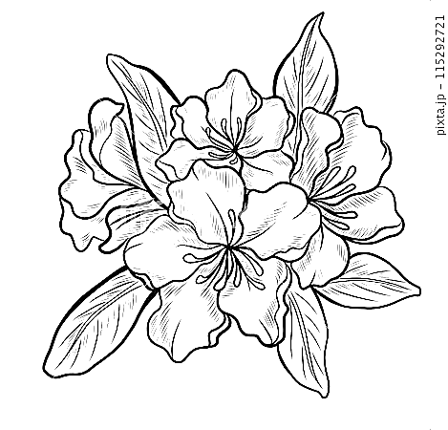**Colour it. 10**
2. 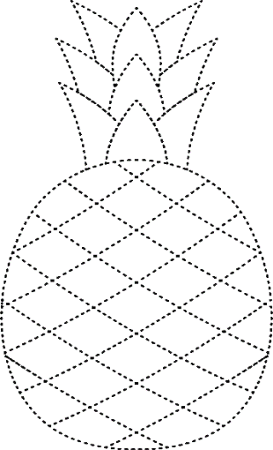**Join the dotted line and colour it. 10**
3. **Draw a picture of butterfly and colour it. 10**
4. **Complete the half picture and colour it. 20**

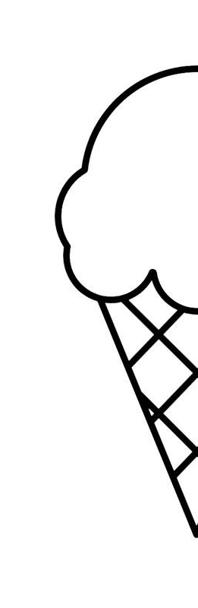

**The End**